St. C Junior High
2009 Summer Camp


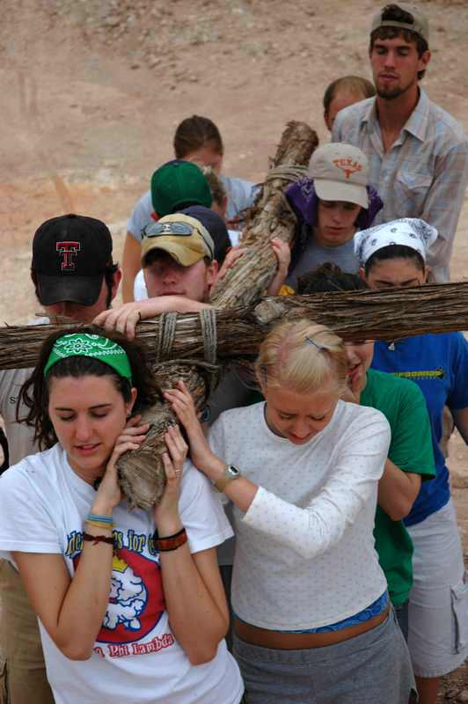
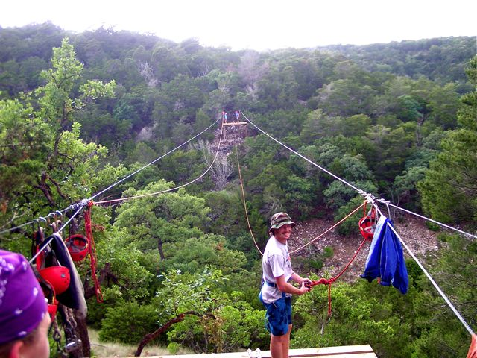

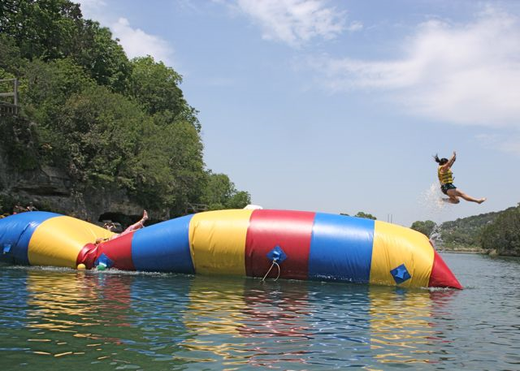

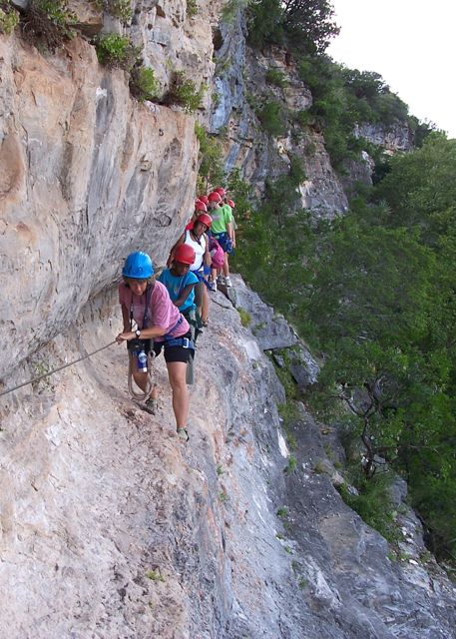

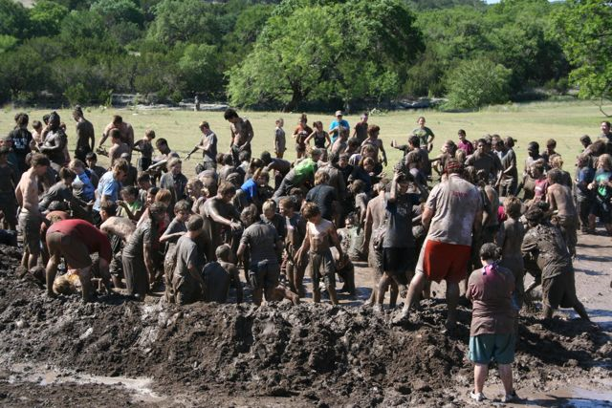

Sunday, August 8 – Friday, Aug 13
Camp Eagle



Dear Friends:

With great excitement, I present this information packet outlining our summer trip to Camp Eagle located in Rock Springs, Texas. The decision regarding the camp and location was not taken lightly. It took much deliberation, thoughtful discussions, and prayers before we decided this is truly the best option for this particular summer of 2010. We believe this trip will be awesome and one filled with new friendships, fun and spiritual growth.

If after reviewing this packet you have any questions about the trip, do not hesitate to contact me. I look forward to a great trip.

Yours in Christ,

Britney Maxwell

Director of Children and Youth Ministries
St. Cuthbert

britney@stcuthbert.org
281.462.7330

Table of Contents

Table of Contents……………………………………………………………………………………………….…….3
What is Camp Eagle? 4
What will we be doing there? 6
Who is invited? 7
How much does it cost to go? 8
Is there a policy about alcohol and drug use? 8
Is there a policy about sexual harassment and conduct? 9
What should I bring? 10
How do I sign up? 10
Application Form…………………………………………………………………………………………………..- 11 -
+


Here you will learn about the main premise to Camp Eagle answered by Camp Eagle themself!
CAMP EAGLE’S MISSION: to inspire Christ-like change through Outdoor Adventure, Authentic Relationships & Biblical Truths

What is CE all about?
We are a weeklong, high intensity; very purposeful, ministry-driven youth adventure camp for middle school, junior high and high school students that is unlike anything you have ever seen. We hire approximately an 80-person summer staff who, along with our 13 full-time staff, strive to create an environment where you don't have to do anything but sit back, get refreshed, and start (or further) relationships with your students for a unique week that will be talked about for months and years to come.
How long are the sessions?
All camp sessions are One Week, Sunday to Saturday, and usually end up with a quiet ride home!
To talk to someone or ask a specific question, please call or email:
Summer Camp Director, Chris McWatters 830.683.3530 chris@campeagle.org
Assistant Summer Camp Director, Debbie Webel 830.683.3533 debbie@campeagle.org
What is your Statement of Faith?
We believe that there is one God eternally existing in three persons:
The Father, the Son and the Holy Spirit.
We believe that the Bible is God's written revelation to man and that it is verbally inspired, authoritative and without error in the original manuscripts.
We believe in the deity of Jesus Christ, His virgin birth, sinless life, miracles, death on the cross to provide for our redemption, bodily resurrection and ascension into heaven, present ministry of intercession for us, and His return in power and glory.
We believe in the personality and deity of the Holy Spirit that performs the miracle of new birth in an unbeliever and indwells believers, enabling them to live a godly life.
We believe that man was created in the image of God, but because of sin, was alienated from God. Only through faith in Christ alone for salvation, which was made possible by His death and resurrection, can that alienation be removed and eternal life secured.

What affiliation or church are you backed by?
We are a non-denominational camp with no affiliation to any one church. We're a 501(c)3 camp, retreat center , and off road race site that was created to serve the church, and introduce the adventurist to a life with Christ. Every summer, we have the honor of seeing a body of believers come together from all over Texas, Louisiana, New Mexico, Arkansas, Oklahoma, and other states, from just about every denomination that believes in our same Statement of Faith.

How do you handle the differences in denominations?
Camp Eagle goes by the "Reiswig Philosophy" - The main thing is to keep the main thing, the main thing.
We can do this for two main reasons.
1. We are staff-led. Which means even though there are 300+ campers on property at one time, we are on 1400 acres, and you will have your own personal counselors (that are all lifeguard certified, first aid certified, belay certified, team building/ropes course certified, and passionate about our mission statement) with you the whole week. You and your leaders can interject with any specifics your denomination believes at any time. The counselors stay away from those topics in general Bible Studies. If your counselors are from a different denomination, they don't voice their opinion on those topics unless a camper asks them specifically in a one-on-one setting. We strive to provide a great balance of having the energy of all the campers together, and giving you the feeling that your group is the only one here throughout the days and nights.
2. We are experienced-based. We believe people (especially teens) remember 10% of what they are told, and up to 90% of what they experience. So that is what we focus on. We don't hire big name speakers, we don't ask your students to sit and listen to someone blab on a microphone to the entire camp for extended lengths of time, and we don't have free time throughout the day because there isn't enough to do. Everything done here is purposeful

What about the background of the theme and experiences?
All year long, our full time camp staff and interns constantly seek God's voice, and intentionally come up with a theme for the summer that is relevant to what students are going through on a daily basis. Then a scripturally based sub-theme for each day is developed. Once we have that, we come up with a broad, and diverse Bible study curriculum. Then we create experience after experience that will allow the campers to be constantly submerged in the Truth. After that, we set up the counselors to know how to consistently keep the day focused on conversations and activities that further drive these points home. And finally, we stay flexible to the way God shapes each week. We will spin the themes, adjust our plans, and keep the counselors ready to roll for your group's specific needs as they appear to us. We know God will supply our energy, so we are able to go beyond what most guests expect for each and every group that comes here.
Again, everything done here is purposeful. We eat family-style, the praise and worship team directly feeds into the experiences, the Bible studies lead into focused conversations, the All-Camp Activities help bring groups together and drop down some barriers for the counselors and your leaders. And then, there are the activities!
Tell me all about the Activities.
We are known for our Adventure activities all around the U.S. Our 1,400 acre property lies in the foothills of the beautiful Texas Hill Country-- with a few different cliffs, including up to a 180 foot drop where we Rock Climb, Rappel, Traverse, Zip, Trek, and do many other cliff-side activities that challenge the most experienced adventure enthusiasts, and also cater to the couch potato that doesn't mind being stretched a little bit. And then there is the Nueces River. We are on the headwaters of this gorgeous, crystal clear, spring-fed water. Here we get to Kayak, Swim, Blob, climb the Iceberg, Water Zipline, challenge the Joust, Rings, Assault, Handline, plus some on the American Gladiators Set. Add to those things seemingly endless numbers of group development activities that are scattered throughout the woods, all along the cliffs, out in the backcountry, and all over the river.
And for times that relaxing is the best "ministry tool" to use, we have a sweet Coffee Shop, Gameroom, Camp Store, Swimming Pool, B-ball / Tennis Court, Beach Volleyball Courts, Tetherball, Horseshoes, a sweet Bouldering Wall, with tons of overhangs, a Games Field, and we're adding every all the time. You can't get all these activities at one spot anywhere else in the country.

What will we be doing there?

Everything is purposeful at Camp Eagle. Pay attention to this part, this is (kind of) our schedule as well.

The Morning:
We will all meet together for some super-energetic "Morning Chaos" after an awesome breakfast (our food is renowned for being tasty, as healthy as possible, and plentiful). From there, we will frontload the day with an intro to that day's theme, and then a hard-hitting question or two that the students will be asked to spread out for a "5 for 5"(a solo time for 5 minutes, 5 feet from everyone else to ponder and talk to God).
The Day:
After this time, your group (of no more than 26 students per group) will head out with their two counselors to enjoy the day. They will walk them through 3 activity rotations, where the counselors will point every experience that takes place toward the theme for the day. They will also engage the students in a conversational Bible study/discussion time at one of the endless scenic spots around the property. Counselors are not allowed to do Bible studies at main camp, and especially not in a room indoors anywhere.
The Evening:
After an awesome supper, oftentimes outdoors somewhere, we will end up with everyone back together for a big-time evening experience. This will include hitting them with the scripture again, the main idea of the day's theme, worship, prayer, and an active experience that (God-willing) will bring that scripture and everything that happened through the day, to life. Thus allowing the students to see, hear, touch, feel, smell, and hopefully truly understand that Biblical lesson between them and the Lord.
The Night:
After the experience, the counselors will usually de-brief it, allowing you and your leaders to hear what the students are going through within their own hearts and allowing everyone to pray together. The evening experience has no cut-off time. Usually worship goes on for a long time. Some evenings your group will be done by 9:00 and can relax at the Bouldering Wall, Games Field Area, the Coffee Shop, the Game room, or back in their rooms. But other nights, your group(s) may go until 2:00 in the morning, and our counselors will be right there with the whole group or the one student dealing with their junk. Also, you can meet with your students on your own, or if you bring more than one group of students, you can get all your crew together and de-brief them on your own, celebrating what God has shown them that night.
But with all that, know that we may bust up the entire "schedule" to bring home a point from scripture through a Simulation, or a day-long experience. The students never know what is coming next.

Who is invited?
This is a trip organized and planned for junior high school students (those students currently in 6th grade – those in 8th grade). However, all members and/or active participants of St. Cuthbert Episcopal Church and their families and friends are welcome to apply. If you are chosen to attend as an adult, parent, high school student, college student, etc. you are attending as a leader or advisor to our youth. As such, you will be given additional responsibility and we expect you to act in an advisory role at all times.

Priority will be given to those active in EYC, the St. Cuthbert Youth Group. It is mandatory for participants to help with our fundraisers, meetings, and events which participants should attend prior to taking this faith journey. If you are unable to attend these meetings (because of your physical location, your schedule, your job, etc.) you will be required to cover the information on your own.

Are high school or college kids invited?

See section “Who is invited to attend?” This is a mission trip organized and planned for junior high school students. If you are chosen to attend as an adult, parent, high school or college student, etc. you are attending as a leader or advisor to our junior high youth. As such, you will be given additional responsibility and we expect you to act in an advisory role.

Are parents invited?

See section “Who is invited to attend?” This is a mission trip organized and planned for junior high school students. Parents are invited. We leave it between you and your junior high school student. If he/she would like to have you join us, then we’d welcome parents. If he/she prefers you not attend, we leave it up to you.

Are friends invited?

See section “Who is invited to attend?” This is a mission trip organized and planned for high school students. All members and/or active participants of St. Cuthbert and their families and friends are welcome to apply. That being said, priority will be given to junior high school aged students that are active members of EYC and other St. Cuthbert activities.

If too many people have applied, how will you pick?

First thing we will do is try to get additional transportation. In the event that we are unable to do this, priority will be given to those youth who are most active in our youth programs at St. Cuthbert. From there, we will give priority based on seniority with regards to seniors before juniors, juniors before sophomores, sophomores before freshman, etc. Again, participation in St. Cuthbert’s Youth activities and programs is more important than age or seniority.

That goes for the advisors as well! It is important for our youth to have the opportunity to develop relationships with the advisors on these mission trips. If you are not active at St. Cuthbert and do not plan to become an active participant in the youth programs, you’re welcome to apply… but priority will be given to those that are active.

How much does it cost to go?

If you are selected to participate, the total cost for the trip will be approximately $325 per person. All transportation, food, lodging, and fees will be included in this amount. Additional spending money is up to you, but do not bring excessive amounts of cash.

If this cost is the only thing keeping you from attending, please contact Britney Maxwell (britney@stcuthbert.org) or call 281.463.7330 and she will help you apply for a scholarship.

- The first deposit of $150 will be due Friday, April 9 by 5:00 PM

  - Along with this deposit the applicant will need to provide a completed application.

- The final payment of the remaining balance will be due Friday, June 25 by 5:00 PM

Is there a policy about alcohol and drug use?

Yes, we have a ZERO TOLERANCE policy with regards to alcohol and illicit drugs. The ZERO TOLERANCE policy is explained below. If you have any questions, concerns, etc. please contact Britney, Reverend Janet Gilmore, or Father Desmond Goonesekera.

Can we participate in illicit drugs?

No. You will be sent home immediately if you are participating in the buying, selling, or act of doing any illegal drugs. In addition, any “legal” drugs should be run by our adult advisors so they know and understand what is going on.

Can I use tobacco products?

If you are under the age of 18, you may not use tobacco products.

Can we drink alcohol?

No. This is a mission trip organized and planned for junior high school students. If you are chosen to attend as an adult, parent, etc. you are attending as an advisor to our wonderful youth. All members of this trip must sign an agreement stating that he/she will NOT consume alcohol on the trip. Period. If you are caught violating this rule (regardless of your age) you will be sent home immediately and at your own expense. If you are under the age of 18, you will also be required to pay for an adult to travel home with you and you will be responsible for paying for him/her travel.

Is there a policy about sexual harassment and conduct?

Yes. This is a trip organized and planned for junior high school students. While there is very little “free time” there will be periods when youth are not closely watched by the adult advisors. We expect youth and adults to conduct themselves in a professional manner at all times. That being said, we were all in junior high school once and we realize that anytime you put youth together for a week, relationships are bound to form. Relationships are cool and totally acceptable. In fact, we encourage this trip to be an opportunity to grow in your relationships with each other! That notwithstanding, youth are not to participate in any type of sexual behavior while on this trip. It is simply not the time, place, etc. for this. Youth will be required to sign a covenant stating they will not participate in sexual behavior while on this trip, even if they are already in a committed relationship prior to attending.

If it comes to the attention of an adult advisor that any youth is acting in a way that does not reflect the values of St. Cuthbert Episcopal Church or the values of the adult leaders on the trip, we will use our best judgment to take care of the situation. If it is not rectified, we will send the youth home at his/ her own expense.

If you are caught violating this rule you will be sent home immediately and at your own expense. If you are under the age of 18, you will also be required to pay for an adult to travel home with you and you will be responsible for paying for his/her travel costs.

The males and females will have separate sleeping areas and each will be prohibited from spending time in the other sleeping area after “lights out.”

If you are caught violating this rule you will be sent home immediately and at your own expense. If you are under the age of 18, you will also be required to pay for an adult to travel home with you and you will be responsible for paying for his/her travel costs.

If you are chosen to attend as an adult, parent, high school or college student, etc. you are attending as an advisor to our youth. As such, you will be given additional responsibility and we expect you to act in an advisory role at all times. This means you may not participate in any way whatsoever in any sexual behavior with any youth. If this occurs, you will be sent home immediately at your own expense. This includes but is not limited to kissing, cuddling, excessive touching or excessive public displays of affection, etc. This is a ZERO TOLERANCE policy and any violation will result in you being sent home immediately.

If you are caught violating this rule you will be sent home immediately and at your own expense.

What should I bring?

SLEEPING:
◊ Sleeping Bag or Sheets and Blanket – twin-size mattresses
◊ Pillow

CLOTHING:
◊ T-shirts -Bring shirts that you won't have problems getting dirty. Please use discretion when choosing shirts.
◊ Shorts -Bring several pairs. Please use discretion when choosing what types of shorts to bring. If shorts are too short, you may not be allowed on some activities.
◊ Shoes –Hiking/walking shoes - don’t bring brand new shoes. Mud shoes - they won’t be ruined, just made muddy. Back-ups - you may get a pair wet, blisters can get bad quickly out here.
◊ Socks & Underwear – bring extras of both – it’s Adventure Camp!
◊ Rainwear – Parka or poncho
◊ Hat/Bandana – Protecting your face, neck, and head from the sun will make life better.
◊ Swimsuit –We love to get wet. More than one is advisable. Ladies – bring a one-piece please.
◊ Water shoes/Sandals – The area is rocky, flip flops are not a good idea.
◊ Jacket / long sleeves – It can get cool quickly out here, even during the summer.
◊ Jeans / long pants – for adventures and staying warm.

BATHROOM STUFF:
◊ Toiletries - toothbrush, toothpaste, shampoo, deodorant, soap, flip-flops for shower.
◊ Towels – for shower and for river / pool swimming (2 or 3 is a good number)

EXTRAS:
◊ Water bottles – more than one would be great (reusable)
◊ Flashlight with extra batteries
◊ Sunglasses
◊ Sunscreen, Chap Stick, Insect Repellent
◊ Bible, Notepad, Pen
◊ Backpack
◊ Watch
◊ Spending cash – you don’t need any, but you’ll have times to buy snacks in the Coffee Shop, Game room, and Store.
◊ Camera/film/batteries
◊ Medications -All Dr. prescribed meds must come in prescription bottle with directions as to how much, and time(s) of day they’re needed.

DON’T BRING ITEMS
◊ MP3 Players, any electronics (cell phones don’t even work out here)
◊ Two way radios/ Walkie-Talkies
◊ Knives or anything sharp, Explosives, Fireworks, Guns, Ammo, etc.
◊ Pets (not even the little cute pets)
◊ Tobacco Products or Alcohol
◊ Perfume or strongly scented lotion
◊ Anything if lost or stolen would result in you being exceedingly depressed or bummed out

How do I sign up?
Fill out and turn in this application form and turn in $150 deposit by 5pm on Friday 4/9/10.

St. Cuthbert Episcopal Church
Jr High Summer Camp

Name:
(As it will appear on my ID) (Name I like to be called)

Address:

Phone: ___________ ____________ _______ E-Mail: _________ ___________________

Birth Date: School/Grade: (Sept. ‘07) ________ _______

Employment:

Church Membership—St. Cuthbert: Other:

Give a brief description of past and current volunteer community or church activities in which you have been involved

The living conditions on this trip will be very simple. The weather will be hot. What consideration have you given to your ability to work hard and be flexible under such conditions?

If I am chosen to participate in this project, I agree to do the following:
-Participate in fund-raising activities for the project.
-Be present at orientation meetings and return money and forms when they are due.
-Abide by the rules and guidelines for behavior and safety while at Camp Eagle.

Signed: Date:
(Applicant)

For Parent/Guardian: I approve the application of my daughter/son for this project and I will be supportive of his/her commitment and responsibilities. I agree to accept full responsibility for any extra travel expenses incurred if it becomes necessary for my daughter/son to return home early because of illness or her/his failure to uphold the rules of participation of the Mission Trip.

Signed: Date: .
(Parent/Guardian)

Send this application & $150.00 deposit by 4/09/10 to:
St. Cuthbert Episcopal Church
ATTN: EYC Jr High Camp
17020 West Road
Houston, TX 77095

* I realize this is a non-refundable deposit. Please make check to “St Cuthbert Church” & in the memo reference EYC Jr High Camp.

